THE
HORMONAL
MAIL
THE OFFICIAL QUARTERLY NEWSLETTER OF CLASSIC LIVESTOCK MANAGEMENT
SERVICES.

VOLUME 1. NO.21.
July 2011

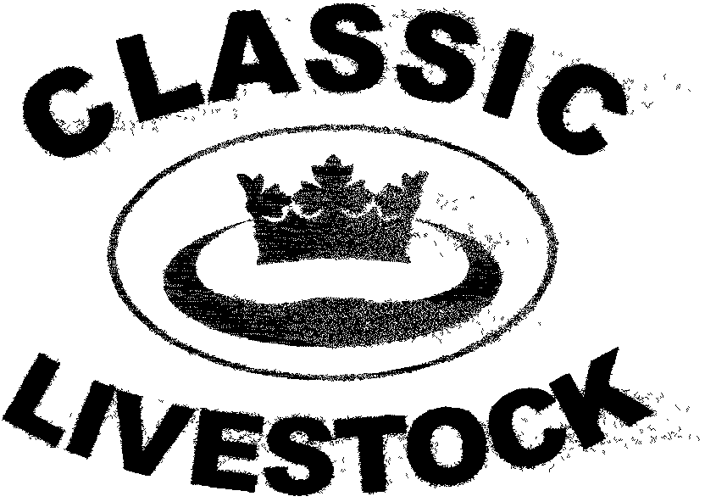

ACN 092435571
P.O. BOX 1181, PHONE: 0741297029/0411201879.
MARYBOROUGH, QLD. 4650.
Email:gewyatt@bigpond.com
Website:www.classiclivestock.com
EDITORIAL.
The biggest disaster to hit the Australian cattle industry for many years did so late last month with the live export ban to Indonesia. Everyone who is anyone has had their comments about the situation and there is no doubt that the industry will suffer greatly for quite a long time to come. Whilst the media releases of treatment of cattle in the Indonesian abattoirs was horrific to say the least there is little to be gained from playing the blame game. Everyone is wise in hind sight. The issue now is to fix the problem and whilst this may never return the export market in Indonesia to its original numbers, it will start to provide those producers who were affected with a return to getting an income. The question is how quickly this will happen and that is going to be a significant factor in the viability of some producers and the relationship between Australia as a provider and Indonesia as a valued market. The reaction of the government here to implement a blanket ban on the trade raises some questions about the thought that went into the decision. I guess we could wonder whether they did consider continuing the trade with abattoirs who complied with the International and Australian standards. Whilst this would have only been a greatly reduced number of cattle, it would have continued some inflow of funds to producers and added assurances to the market that every effort was being made to maintain the trade to the best of the supplier’s ability given the circumstances. Everyone has there opinion, but that isn’t fixing the problem so let’s hope those in the position to do so continue to work hard to restore some, at least, of the business.
Let’s hope that the current fall in the cattle market in southern Qld and the Eastern states is not accentuated to any great degree by a possible flood of cattle from the north in the next few months.
WHAT’S HAPPENING
*We have finished grading another 30 cattle that have just been processed. We have taken fat samples and sent these to the University of Adelaide for testing for omega 3 levels. The aim is to have these 30 samples tested to bring the total done in the last 9 months up to 50 and this should give us a good indication as to the relationship between animals grading high on the CLMS grading system and those that have above average levels of Omega 3.
We would like to determine what if any correlation there is between the cattle we have graded as having high quality meat and omega 3 levels in the fat. The first 20 samples we did indicated an 80% correlation between omega 3 levels and tenderness.
There were a few more (approx. 10) samples from grass fed meat in this last sample so we should get and idea of any variation between grass and lot fed meat although most of the grain fed cattle in this ample were only on grain for 70 – 80 days and during the early part of their grain feeding were also getting some grass.
Unfortunately, there were not as many of these cattle that graded poorly as I would have liked to give a more even idea of the results, but this sample should still give some indication of any correlation.

*We attended the first stand alone sale for Coodardie Brahmans for many years in May at the Mataranka (Northern Territory) rodeo grounds. The O’Brien family are to be congratulated for the way the animals were presented and the professional way that the sale was promoted and conducted. 75 bulls and 68 heifers were offered with all the heifers and nearly 60 of the bulls being sold. Whilst there were no record prices, the family were satisfied with the result and most of the remaining bulls have been sold privately since that date. The sale may not have been as successful if it had been held a month later with the way things have developed recently.

*We are giving a lot of thought to holding a field day around the 15th. of August to promote our system. There are still a few loose ends to pull together, but we are hoping it can happen. We have been considering doing this for some time and this may be an opportunity for us to make a start with such events. One of the attractions for us to do this is that we may have an opportunity to have an overseas guest presenter who is very well known internationally in the industry. Confidentiality prevents us from disclosing who it is at present, but when we can confirm his availability and confirm other details we will email everyone on our list and advertise in the local press. The plan at present is to hold the event at the Nanango showgrounds where there are very good yard and people facilities for such a day.

*We are continuing to talk to people in all sections of the meat production chain to establish a market pathway for CLMS graded meat. We have a small abattoir willing to process cattle and we have some producers who could supply a limited quantity of graded cattle at present. I have also spoken to a couple of butchers who would consider selling a CLMS branded product. There are still a few more details to get in place and then coordinate the whole operation so that we can ensure that it works. Another option is to develop an online market which could end up being logistically more workable than the traditional market chain. We welcome any input from any people in the market chain who would be willing to work with us.
CLMS - A CATALYST NOT A CLUB
I find it interesting to be able to discuss with producers those areas of their business that are not as effective as they would like and asking them what they would change that would lead to obtaining more balance in their enterprise. Quite often it is about our approach or attitudes and these can vary as much and as often as the weather. One of the great things that I have observed is that those producers who know themselves well also know the other parts of their business well and they have a stillness within that is very powerful to witness. This state of mind enables them to make the decisions that are going to support the values they have developed to build their business on.
Sure, there are going to be times of self doubt and self examination. However, these are important as well because they allow you to ask the hard questions about the decisions you are making. In other words, it is part of checking the ecology around your decisions. Asking the right questions is critical and they aren’t necessarily the ones you have immediate answers for either or are they straight forward questions. Asking the right type of question is the key to getting the best answer for your particular situation, plan etc. Ultimately, though, if your decisions are not congruent with, and supportive of your values, then the chances of success are limited. Being congruent with your values equals commitment and that is a large part of success. We discussed a process around values in the January 2010 newsletter No. 15 that I would encourage you all to look at again if you have any doubt about the importance of values and asking the right questions.
As a company, we don’t see our role as one of advising producers and breeders what they should or should not be doing in their enterprise. We would hope to be more of a catalyst to encourage clients to consider options they may not necessarily have thought of previously and to bounce ideas of us. Whether they adopt any of those ideas is entirely up to them. There are some things that we give some specific information about in regard to our evaluations, particularly to things like meat and milk quality and hormonal activity when we are evaluating cattle. Some of the confirmation traits are also fairly set in how they should appear. However, there are a range of other considerations, especially environmental, that will vary considerably between geographic locations and these are best known by the local producer and breeder and we don’t believe it is our role to change what already works in that local area. Neither is it our role to try and influence breeders as what breed they prefer or how they are going to develop that breed or variation of breeds. As I have said previously, the breeder ultimately knows what they can commit to most fully and that is going to go a long way to giving them the best outcome for their enterprise in the long run.
Certainly, we are willing and happy to be the sounding board for producers and breeders as they work through the options that they have, but we encourage people to come up with their own solutions and if we can throw in a couple of questions from left field that assist our clients to elicit a better solution and better outcome for their business then we would consider we have gone a long way to filling our role.
It is immensely satisfying and rewarding to see people work through their planning process for their enterprise and come out the other end with a sound, well developed plan with options and flexibility and above all, the enthusiasm and excitement to implement it with commitment and vision.
******************************************************************
CHECKING OUT REAL FAT
Some of this following piece you may already be familiar with if you have read our book, “The Vision Tender” or an earlier newsletter. However, the topic is still very relevant and I want to keep it to the forefront because it is something we all need to be aware of for a number of reasons. As I have said earlier in this newsletter, we are doing some trials at present on Omega 3 levels in cattle that we have graded for meat quality. We would have preferred this work to have been done by an independent researcher, but we have not been able to find anyone who is willing to do it so we have decided to do it ourselves in the hope of generating more interest.
One of the most frustrating things for livestock producers must have to be the gross generalizations made about fats by health and diet professionals. Because of at least some of these statements, the general public has been misled about the truth in regard to the fat contained in animal products with the result that many people don’t buy them today.
We believe that there has not been enough research conducted on the key differences between animal’s fats nor their impact on human health. Our company has already published some views on our website: www. classiclivestock.com about the need for more research into these variations in different types of fat. Our interest goes even further because we believe that it is possible to visually and kinaesthetically distinguish between animals, for example, that are high in poly unsaturated fats as opposed to those that are high in saturated fats.
Animals, and cattle in particular, disclose so many other facts about themselves, their health and their productive capacity by what they display to us on sight and what we can feel when we touch them, that it is quite feasible that they will also tell us about their fat quality in the same way. We haven’t scientifically proven the hypothesis as yet, but our experience and taste tests have indicated that there is a correlation between milk quality, meat quality, fat quality and the evaluated grade of the traits that we have identified as being necessary for animals to produce these quality products.
This research needs to be done to reduce the number of generalized statements that are being made about this topic without enough solid scientific foundation. We are not saying that the hypothesis we are proposing will necessarily be proven one hundred percent correct. However, every livestock producer in the world needs to be aware of what is happening in the health food industry and support research that will clarify such hypothesis as the one we have proposed. Certainly, our company has a vested interest in being able to prove the hypothesis, as we have a system that has the potential to grade animals for fat quality and therefore influence breeding programs so that only animals high in the “good fats” are selected for future breeding.

THE ROLE OF FATS.
Fats provide a concentrated source of energy for the bodies of both humans and animals. They provide important compounds for the development of cell membranes, hormones, prostaglandins (important in reproduction) and other molecules. Fat also assists in the absorption of vitamins A, D, E, (essential for good cattle health) K and carotenoids, which are critical for plant photosynthesis, colorants in animals and as recent research has shown, in providing anti oxidants and regulating the immune response system.

Fat plays an important role in the diet of both humans and animals. The question is the amount rather than anything else, although some types of fat should only be eaten in very small amounts.
Fat types are recognizable when examined under laboratory conditions by their molecular structure. Fatty acids are molecules that contain carbon atoms bonded to other carbon atoms. It depends on the relationship of these carbon atoms to each other as to the type of fat that it will be. There are four main different types of fat. They are: Saturated, Monounsaturated, Trans fat and Polyunsaturated fats which are the better of the four main types.

CURRENT GRADING
In many of the grids used today by meat processors to measure the quality of a carcase, fat and fat depth or thickness plays a large part. We would question just how relevant fat is to the quality of meat and in particular, the depth. We feel there is certainly a correlation between fat and the palatability or taste of the meat and this can be influenced by the feed that the animal eats prior to processing as well as to its overall feeding and growth history.
However, we would strongly question its relationship with tenderness. At best, the interspersion of fat particles in the muscle of the meat, commonly known as marbling, will give a perception of that meat being tender. However, if that fat could be removed the remaining meat may well not be as tender. We feel that a more accurate measurement of the fat’s importance to the particular meat would be to test it for the level of unsaturated fats and then compare that to the tenderness of the meat it comes from.
**********************************************************************************

BREED OF THE QUARTER
BANTENG (Also spelt Bantang)
The Banteng (Bos Javinicus) are a tropical breed of cattle that originated in South East Asia. They are believed to be one of the original tropical cattle breeds and can be found in several South East Asian countries, though they differ slightly in colour and size in some countries. They were first introduced into Northern Australia in 1849 at a British outpost on the Coburg Peninsula. Twenty animals were taken to Western Arnhem Land as a source of meat. About a year after they were brought to the area, the outpost was closed and the remaining cattle were freed to run in the bush and become a feral population. By the 1960’s, their population had grown to an estimated 1500 head and in 2005 there was an estimated 10,000 head on the Coburg Peninsula, making it the largest Banteng herd in the world. They breed very true to type because they are all ancestors of the original herd in the area.
They have also been integrated into some of the cattle herds of Northern Australia and because of their original domestic history have fitted into these other herds though they are probably a little more inclined to be flighty or more alert than some of the other tropical breeds.
The Banteng is similar, or just slightly smaller in size to Brahman cattle and most of the other tropical breeds. Mature males are shorter haired in the coat, which is a blue-black or dark chestnut in colour, while in females and calves it is chestnut with a dark dorsal stripe. Both males and females have white stockings on their lower legs, a white patch under their tail, a white muzzle, and white spots above the eyes. The build is similar to that of most domestic cattle.
They have a comparatively slender neck but without the really distictive hump that most tropical breds, especially the brahman have. They tend to have a slight ridge along the back above the shoulders. Both males and females have horns.
I have evaluated a few Banteng and Banteng cross cattle at Coodardie Station in the Northern Territory and found that their confirmation is consistent and their meat quality good and also consistent across the breed. I also know of another small herd near Yarraman in Qld.
*****************************************************************
OLD DOG WISDOM!!!!
An old German Shepherd starts chasing rabbits and before long, discovers that he's lost. Wandering about, he notices a panther heading rapidly in his direction with the intention of having lunch.
The old German Shepherd thinks, "Oh, oh! I'm in deep sh** now!"
Noticing some bones on the ground close by, he immediately settles down to chew on the bones with his back to the approaching cat. Just as the panther is about to leap, the old German Shepherd exclaims loudly,
"Boy, that was one delicious panther! I wonder, if there are any more around here?"
Hearing this, the young panther halts his attack in mid-strike, a look of terror comes over him and he slinks away into the trees.
"Whew!," says the panther, "That was close! That old German Shepherd nearly had me!"
Meanwhile, a squirrel who had been watching the whole scene from a nearby tree, figures he can put this knowledge to good use and trade it for protection from the panther. So, off he goes.
The squirrel soon catches up with the panther, spills the beans and strikes a deal for himself with the panther. The young panther is furious at being made a fool of and says, "Here, squirrel, hop on my back and see what's going to happen to that conniving canine!"
Now, the old German Shepherd sees the panther coming with the squirrel on his back and thinks, "What am I going to do now?," but instead of running, the dog sits down with his back to his attackers, pretending he hasn't seen them yet, and just when they get close enough to hear, the old German Shepherd says...
"Where's that squirrel? I sent him off an hour ago to bring me another panther!"
Moral of this story...
Don't mess with the old dogs... Age and skill will always overcome youth and treachery!
Bull Sh** and brilliance only come with age and experience.
**********************************************************************************
Thank you for your continued interest in our newsletters, our website and our book. Please feel free to order one of our books and become familiar with the CLMS system and the directions we are taking in the overall scheme of animal and food production for human consumption
PLEASE FEEL FREE TO CONTACT US ABOUT ANY ITEMS IN THIS NEWSLETTER, ON OUR WEBSITE OR IN OUR NEW MANUAL. WE WELCOME PRODUCER INPUT AND INTEREST AND WANT TO INVOLVE YOU IN WHAT WE ARE DOING.
Disclaimer: - Information contained in this newsletter is believed to be true and accurate at the time of publication. Classic Livestock Management Services is not liable to any person or organisation, whether in negligence or other wise for anything published in, or omitted from this publication.

